A Study on ETL, Data Engineering Tools and Their Industrial Applications

# ETL Pipeline Diagram

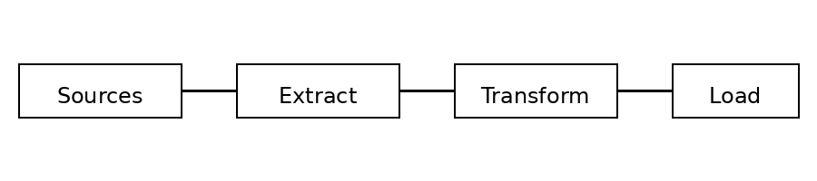

# Introduction

In today’s digital world, companies generate huge amounts of data from applications, websites, sensors, and users. Raw data cannot be used directly for business decisions. It must be collected, cleaned, and organized. ETL (Extract, Transform, Load) is the backbone of modern data systems and is widely used in analytics, reporting, and machine learning systems.

# What is ETL?

ETL stands for Extract (get data from sources), Transform (clean and process data), and Load (store it in a target system like a data warehouse or data lake). It helps convert raw data into useful, trusted data for reports and analysis.

# Why ETL is Important

ETL helps combine data from multiple sources, improves data quality, removes duplicates and errors, and makes data ready for dashboards, reports, and machine learning.

# ETL Pipeline (Overview)

1) Data Sources → 2) Extraction → 3) Transformation → 4) Loading → 5) Orchestration & Monitoring. Sources include databases, files, APIs, logs, and sensors. Transformations include cleaning, joining, validating, and creating new columns.

# Popular ETL Tools

1. **Cloud ETL Tools**:
   1. AWS Glue: It is a serverless ETL service that automatically scales and integrates well with AWS data lakes and S3. It is mainly used to prepare and catalog data for analytics.
   2. Azure Data Factory (ADF): It is a cloud-based data integration service used to build ETL/ELT pipelines. It supports many data sources and is widely used in Azure ecosystems.
   3. Google Dataflow: It is used for both batch and streaming data processing. It is built on Apache Beam and is suitable for large-scale data pipelines.
2. **Enterprise ETL Tools**:
   1. Informatica: It is a powerful enterprise ETL tool used in big companies for complex data integration. It supports data quality, governance, and large-scale transformations.
   2. Talend: It is an ETL and data integration platform that also focuses on data quality and data governance. It is used to build reliable and reusable data pipelines.
   3. SSIS (SQL Server Integration Services): It is Microsoft’s ETL tool used mainly with SQL Server. It is used to move and transform data inside Microsoft-based systems.
3. **Modern ELT / Ingestion Tools**:
   1. Fivetran: It is a fully managed tool that automatically pulls data from many SaaS applications into data warehouses. It reduces manual work and maintenance.
   2. Airbyte: It is an open-source data integration tool that supports many connectors. It is flexible and widely used for building custom data ingestion pipelines.
4. **Transformation Tool**:
   1. dbt: It is used to transform data inside the data warehouse using SQL. It also provides testing, documentation, and version control for data models.

# Complete Data Engineering Tool Stack

• Storage (S3, ADLS, GCS, Snowflake, BigQuery): These systems are used to store raw and processed data. Data lakes store large raw files, and data warehouses store structured data for analytics.

• Ingestion (ADF, Glue, Fivetran, Airbyte): These tools are used to bring data from different sources into the data lake or data warehouse. They support batch and sometimes real-time loading.

• Processing (Spark, SQL, Dataflow): These tools are used to clean, transform, and process large amounts of data. Spark is used for big data processing, and SQL is used inside warehouses.

• Orchestration (Airflow, Prefect, Dagster): These tools are used to schedule and manage data pipelines. They control the order of tasks and handle failures and retries.

• Streaming (Kafka, Kinesis, Pub/Sub): These systems are used to handle real-time data such as logs, events, and sensor data. They help process data continuously instead of in batches.

• Data Quality (Great Expectations, dbt tests): These tools are used to check whether data is correct, complete, and reliable. They help detect missing values, duplicates, and wrong formats.

• Monitoring (CloudWatch, Azure Monitor, Logs): These tools are used to monitor pipeline health, failures, and performance. They help data engineers fix problems quickly.

# Industries Using ETL

• Banking & Finance: Banks use ETL to combine transaction data from different systems to detect fraud, calculate risk, and generate regulatory reports.

• Healthcare: Hospitals use ETL to integrate patient records, lab reports, and billing data into a single system for analysis and reporting.

• E-commerce & Retail: Companies like Amazon and Flipkart use ETL to analyze customer behavior, sales, and product performance.

• Telecom: Telecom companies use ETL to process call records and network logs to analyze usage and predict customer churn.

• Manufacturing & IoT: Factories use ETL to collect sensor data from machines and perform predictive maintenance.

• Logistics & Transportation: ETL is used to analyze delivery times, routes, and fuel usage to improve operations.

• Media & OTT: Platforms like Netflix and YouTube use ETL to analyze watch history and recommend content to users.

 

# Conclusion

ETL and Data Engineering are core components of modern data platforms and help organizations convert raw data into valuable business insights.